STOC 2005

The 37th ACM Symposium on
Theory of Computing

May 21-24, 2005
Marriott Hunt Valley Inn
Hunt Valley, MD, USA

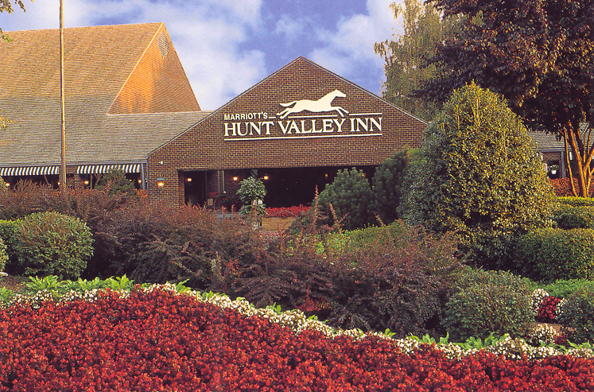

Program

STOC 2005 Conference Organization

SIGACT Chair: | Hal Gabow, University of Colorado
Program Chair:  Tutorials Chair: | Ronald Fagin, IBM Almaden Research Center  Cynthia Dwork, Microsoft Research, Silicon Valley
SIGACT Executive Committee: | Rajeev Motwani (Vice Chair), Stanford University  Eva Tardos (Secretary-Treasurer), Cornell University  Paul Beame (Member-at-Large), University of Washington  David Karger (Member-at-Large), Massachusetts Institute of Technology
Local Arrangements Chair: | Christian Scheideler, Johns Hopkins University
Program Committee: | Gerth Stølting Brodal, University of Aarhus  Harry Buhrman, CWI and University of Amsterdam  Jin-Yi Cai, University of Wisconsin, Madison  Cynthia Dwork, Microsoft Research, Silicon Valley  Ronald Fagin (chair), IBM Almaden Research Center  Martin Farach-Colton, Rutgers University  Anupam Gupta, Carnegie Mellon University  Sariel Har-Peled, University of Illinois, Urbana-Champaign  Russell Impagliazzo, University of California, San Diego  Kamal Jain, Microsoft Research, Redmond  Adam Tauman Kalai, Toyota Technological Institute  David Karger, Massachusetts Institute of Technology  Claire Kenyon, Brown University  Subhash Khot, Georgia Institute of Technology  Ravi Kumar, IBM Almaden Research Center  Moni Naor, Weizmann Institute of Science  Ryan O'Donnell, Microsoft Research, Redmond  Toniann Pitassi, University of Toronto  Tim Roughgarden, Stanford University  Alistair Sinclair, University of California, Berkeley  Amnon Ta-Shma, Tel Aviv University
Local Arrangements Committee: | Rao Kosaraju, Johns Hopkins University  Christian Scheideler, Johns Hopkins University  Aravind Srinivasan, University of Maryland at College Park
STOC 2005 Sponsors & Supporters

The conference is sponsored by the ACM Special Interest Group on Algorithms and Computation Theory

SIGACT
The SIGACT Institutional Supporters are
AKAMAI TECHNOLOGIES
IBM RESEARCH
MICROSOFT RESEARCH
NEC LABORATORIES AMERICA, INC.
The Student Registration Supporter is

IBM RESEARCH

The Postdoctoral Registration Supporter is

NEC LABORATORIES AMERICA, INC.
The Social Event Supporter is

The Johns Hopkins University
The Conference Supporter is

MICROSOFT RESEARCH

Overview

Saturday, May 21: Larry Stockmeyer Commemoration

Sunday, May 22 – Tuesday, May 24: STOC Conference

Sunday, May 22 | Monday, May 23 | Tuesday, May 24
7:30 – 8:30: Breakfast  8:30 – 10:10: Sessions 1A/B  10:10 – 10:35: Coffee Break  10:35 – 11:25: Sessions 2A/B  11:30 – 12:30: Invited talk  12:30 – 1:45: Lunch  1:45 – 3:25: Sessions 4A/B  3:25 – 3:45: Coffee Break  3:45 – 5:25: Sessions 5A/B  8:00 – 10:00: Business meeting | 7:30 – 8:30: Breakfast  8:30 – 10:10: Sessions 6A/B  10:10 – 10:35: Coffee Break  10:35 – 11:25: Sessions 7A/B  11:30 – 12:15: Session 8  12:15 – 1:45: Lunch  1:45 – 3:25: Sessions 9A/B  3:25 – 3:45: Coffee Break  3:45 – 5:00: Sessions 10A/B  5:30 – 11:00: Social event | 7:30 – 8:30: Breakfast  8:30 – 10:10: Sessions 11A/B  10:10 – 10:35: Coffee Break  10:35 – 11:25: Sessions 12A/B  11:30 – 12:15: Session 13  12:15 – 1:45: Lunch  1:45 – 3:25: Sessions 14A/B  3:25 – 3:45: Coffee Break  3:45 – 5:00: Sessions 15A/B

STOC 2005 Conference Awards

The STOC 2005 Program Committee selected two award papers:

- The Best Paper Award was given to Omer Reingold for his paper
Undirected ST-Connectivity in Log-Space
Monday, May 23, 11:30 – 12:15 pm

- The Danny Lewin Best Student Paper Award was given to Vladimir Trifonov for his paper
A O(log n log log n) Space Algorithm for Undirected Connectivity
Tuesday, May 24, 11:30 – 12:15 pm

Floor Plans

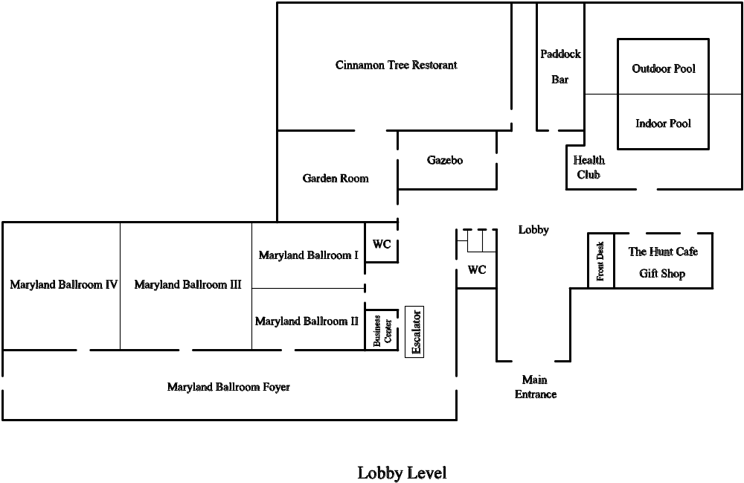

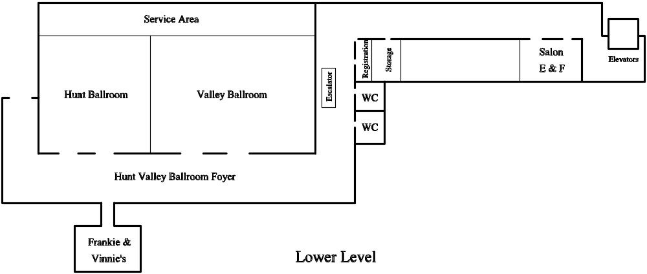

- Registration desk (WLAN & storage): Hunt Valley Ballroom Foyer
- Larry Stockmeyer Commemoration: Hunt Ballroom
- Session A and plenary sessions: Maryland Ballroom
- Session B: Hunt Ballroom
- Breakout room (WLAN & whiteboards): Salon E&F
- Lunch: Valley Ballroom

Larry Stockmeyer Commemoration
Saturday, May 21

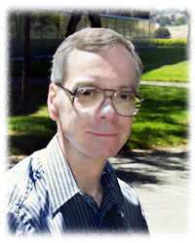
Larry Stockmeyer, a founder of computational complexity, died on July 31, 2004, almost exactly thirty years after completing one of the most remarkable doctoral theses in computer science.

Stockmeyer's technical contributions are as broad as they are deep, spanning complexity theory, logic, interactive proofs, distributed computing, parallel computing, secure architectures, database privacy, and storage systems.

9:15 – 10:45 am:  10:45 – 11:15 am:  11:15 – 11:55 am:  11:55 – 1:30 pm:  1:30 – 2:10 pm:  2:10 – 2:50 pm:  2:50 – 3:30 pm:  3:30 – 4:00 pm:  4:00 – 4:40 pm:  4:40 – 5:20 pm:  5:20 – 5:30 pm: | Nicholas Pippenger  Larry Stockmeyer’s Work in Computational Complexity Theory  Coffee Break  Albert Meyer  What We Were Thinking: A Supervisor’s Reminiscence  Lunch (on our own)  Richard Karp  Congestion-Delay Trade-Offs in Geographically Distributed Networks  Anne Condon  What can be Proved to a Finite State Verifier?  Larry Stockmeyer’s Contributions to Interactive Proof Systems  Miklos Ajtai  Secure Computing  Coffee Break  Christopher Umans  Optimization Problems in the Polynomial-Time Hierarchy  Cynthia Dwork  Larry Stockmeyer’s Last Work et Sequelae  Remarks

STOC 2005 Program

Saturday, May 21

6:00 – 9:00 pm: Reception

Sunday, May 22

7:30 – 8:30 am: Continental Breakfast

8:30 – 10:10 am: Session 1A (Chair: Amnon Ta-Shma)

8:30 am: Simulating Independence: New Constructions of Condensers, Ramsey Graphs, Dispersers, and Extractors
Boaz Barak, Guy Kindler, Ronen Shaltiel, Benny Sudakov, Avi Wigderson

8:55 am: Extractors with Weak Random Seeds
Ran Raz

9:20 am: Pseudorandom Generators for Low Degree Polynomials
Andrej Bogdanov

9:45 am: On Uniform Amplification of Hardness in NP
Luca Trevisan

8:30 – 10:10 am: Session 1B (Chair: Tim Roughgarden)

8:30 am: Approximation Techniques for Utilitarian Mechanism Design
Patrick Briest, Piotr Krysta, Berthold Vöcking

8:55 am: Computing Correlated Equilibria in Multi-Player Games
Christos H. Papadimitriou

9:20 am: The Price of Routing Unsplittable Flow
Baruch Awerbuch, Yossi Azar, A. Epstein
&
The Price of Anarchy of Finite Congestion Games
George Christodoulou, Elias Koutsoupias

9:45 am: Market Equilibrium via the Excess Demand Function
Bruno Codenotti, Benton McCune, Kasturi Varadarajan

10:10 – 10:35 am: Coffee Break

10:35 – 11:25 am: Session 2A (Chair: Jin-Yi Cai)

10:35 am: On Lattices, Learning with Errors, Random Linear Codes, and Cryptography
Oded Regev

10:50 am: Representing Hard Lattices with O(n log n) Bits
Miklos Ajtai

10:35 – 11:25 am: Session 2B (Chair: Claire Kenyon)

10:35 am: On Dynamic Range Reporting in One Dimension
Christian Worm Mortensen, Rasmus Pagh, Mihai Patrascu

10:50 am: Worst-Case Update Times for Fully-Dynamic All-Pairs Shortest Paths
Mikkel Thorup

11:30 – 12:30 pm: Session 3 (Invited talk. Chair: Ronald Fagin)

Beyond NP: The Work and Legacy of Larry Stockmeyer
Lance Fortnow

12:30 – 1:45 pm: Lunch

1:45 – 3:25 pm: Session 4A (Chair: Ravi Kumar)

1:45 pm: Every Monotone Graph Property is Testable
Noga Alon, Asaf Shapira

2:10 pm: Testing versus Estimation of Graph Properties
Eldar Fischer, Ilan Newman

2:35 pm: Testing Monotone High-Dimensional Distributions
Ronitt Rubinfeld, Rocco A. Servedio

3:00 pm: Efficient Testing of Groups
Katalin Friedl, Gabor Ivanyos, Miklos Santha

1:45 – 3:25 pm: Session 4B (Chair: Tim Roughgarden)

1:45 pm: Approximation Algorithms for Network Design with Metric Costs
Joseph Cheriyan, Adrian Vetta

2:10 pm: On Non-uniform Multicommodity Buy-at-Bulk Network Design
Moses Charikar, Adriana Karagiozova

2:35 pm: Multicommodity Flow, Well-linked Terminals, and Routing Problems
Chandra Chekuri, Sanjeev Khanna, F. Bruce Shepherd

3:00 pm: Oblivious Routing in Directed Graphs with Random Demands
MohammadTaghi Hajiaghayi, Jeong Han Kim, Tom Leighton, Harald Räcke

3:25 – 3:45 pm: Coffee Break

3:45 – 5:25 pm: Session 5A (Chair: Sariel Har-Peled)

3:45 pm: Optimal Approximations of the Frequency Moments of Data Streams
Piotr Indyk, David Woodruff

4:10 pm: Coresets in Dynamic Geometric Data Streams
Gereon Frahling, Christian Sohler

4:35 pm: Low Distortion Embeddings for Edit Distance
Rafail Ostrovsky, Yuval Rabani

5:00 pm: Low-Distortion Embeddings of General Metrics Into the Line
Mihai Badoiu, Julia Chuzhoy, Piotr Indyk, Anastasios Sidiropoulos

3:45 – 5:25 pm: Session 5B (Chair: Ryan O'Donnell)

3:45 pm: Tree-Walking Automata Do Not Recognize All Regular Languages
Mikolaj Bojanczyk, Thomas Colcombet

4:10 pm: Balanced Boolean functions that can be Evaluated so that Every Input Bit is Unlikely to be Read
Itai Benjamini, Oded Schramm, David B. Wilson

4:35 pm: Lower Bounds for k-DNF Resolution on Random 3-CNFs
Michael Alekhnovich

5:00 pm: Bounded-depth Circuits: Separating Wires from Gates
Michal Koucky, Pavel Pudlak, Denis Therien

8:00 – 10:00 pm: Business Meeting

Topics:
- STOC PC and local arrangements reports
- Goedel Prize, CRA Outstanding Undergraduate Awards, STOC Paper Awards
- STOC policy on duplicate submissions
- State of theoretical computer science funding

Monday, May 23

7:30 – 8:30 am: Continental Breakfast

8:30 – 10:10 am: Session 6A (Chair: Sariel Har-Peled)

8:30 am: Simple PCPs with Poly-log Rate and Query Complexity
Eli Ben-Sasson, Madhu Sudan

8:55 am: Hardness of the Undirected Edge-Disjoint Paths Problem
Matthew Andrews, Lisa Zhang

9:20 am: Hardness of the Undirected Congestion Minimization Problem
Matthew Andrews, Lisa Zhang

9:45 am: Towards Strong Nonapproximability Results in the Lovasz-Schrijver Hierarchy
Mikhail Alekhnovich, Sanjeev Arora, Iannis Tourlakis

8:30 – 10:10 am: Session 6B (Chair: Jin-Yi Cai)

8:30 am: Computing the First Betti Number and the Connected Components of Semi-algebraic Sets
Saugata Basu, Richard Pollack, Marie-Francoise Roy

8:55 am: Polynomial Time Algorithm for Computing the Top Betti Numbers of Semi-algebraic Sets Defined by Quadratic Inequalities
Saugata Basu

9:20 am: On Algorithms for Discrete and Approximate Brouwer Fixed Points
Xi Chen, Xiaotie Deng

9:45 am: Convex Programming for Scheduling Unrelated Parallel Machines
Yossi Azar, A. Epstein

10:10 – 10:35 am: Coffee Break

10:35 – 11:25 am: Session 7A (Chair: Cynthia Dwork)

10:35 am: The Round Complexity of Two-Party Random Selection
Saurabh Sanghvi, Salil Vadhan

11:00 am: Hierarchies for Semantic Classes
Lance Fortnow, Rahul Santhanam, Luca Trevisan

10:35 – 11:25 pm: Session 7B (Chair: Ravi Kumar)

10:35 am: Learning with Attribute Costs
Haim Kaplan, Eyal Kushilevitz, Yishay Mansour

11:00 am: Learning Nonsingular Phylogenies and Hidden Markov Models
Elchanan Mossel, Sebastien Roch

11:30 – 12:15 pm: Session 8 (Best paper. Chair: Ronald Fagin)

Undirected ST-Connectivity in Log-Space
Omer Reingold

12:15 – 1:45 pm: Lunch

1:45 – 3:25 pm: Session 9A (Chair: Anupam Gupta)

1:45 pm: Universal Approximations for TSP, Steiner Tree, and Set Cover
Lujun Jia, Guolong Lin, Guevara Noubir, Rajmohan Rajaraman, Ravi Sundaram

2:10 pm: Saving an Epsilon: A 2-approximation for the k-MST Problem in Graphs
Naveen Garg

2:35 pm: The Mixing Time of the Thorp Shuffle
Ben Morris

3:00 pm: Approximately Counting Integral Flows and Cell-bounded Contingency Tables
Mary Cryan, Martin Dyer, Dana Randall

1:45 – 3:25 pm: Session 9B (Chair: Kamal Jain)

1:45 pm: Spectral Norm of Random Matrices
Van Vu

2:10 pm: On Random +/- 1 Matrices: Singularity and Determinant
Terence Tao, Van Vu

2:35 pm: On the Average Case Performance of Some Greedy Approximation Algorithms for the Uncapacitated Location Problem
Abraham D. Flaxman, Alan M. Frieze, Juan C. Vera

3:00 pm: Towards Asymptotic Optimality in Probabilistic Packet Marking
Micah Adler, Jeff Edmonds, Jiri Matousek

3:25 – 3:45 pm: Coffee Break

3:45 – 5:00 pm: Session 10A (Chair: Amnon Ta-Shma)

3:45 pm: Tensor Norms and the Classical Communication Complexity of Nonlocal Quantum Measurement
Yaoyun Shi

4:10 pm: Fast Quantum Algorithms for Computing the Unit Group and Class Group of a Number Field
Sean Hallgren
&
Polynomial Time Quantum Algorithm for the Computation of the Unit Group of a Number Field
Arthur Schmidt, Ulrich Vollmer

4:35 pm: Fast Quantum Byzantine Agreement
Michael Ben-Or, Avinatan Hassidim

3:45 – 5:00 pm: Session 10B (Chair: David Karger)

3:45 pm: Quadratic Forms on Graphs
Noga Alon, Konstantin Makarychev, Yuri Makarychev, Assaf Naor

4:10 pm: Lower-Stretch Spanning Trees
Michael Elkin, Yuval Emek, Daniel A. Spielman, Shang-Hua Teng

4:35 pm: Edge Partition of Planar Graphs into Two Outerplanar Graphs
Daniel Goncalves

5:30: Buses leave for social event at the Johns Hopkins University

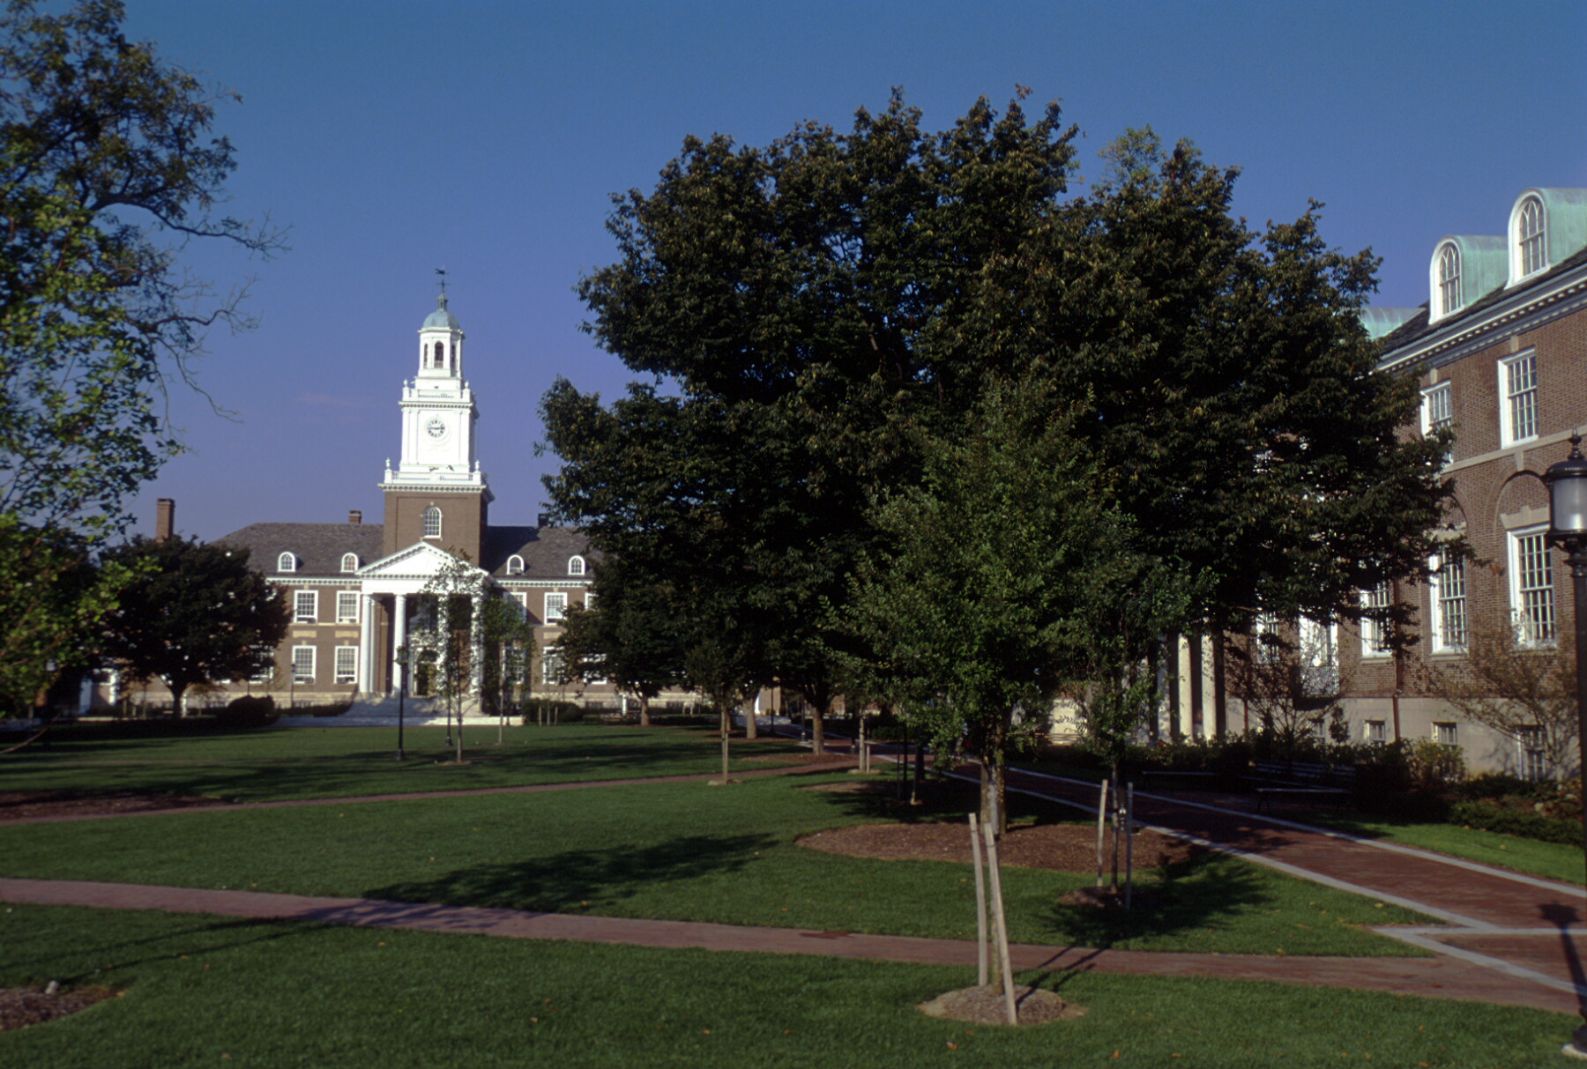

Tuesday, May 24

7:30 – 8:30 am: Continental Breakfast

8:30 – 10:10 am: Session 11A (Chair: Cynthia Dwork)

8:30 am: Covert Two-Party Computation
Luis von Ahn, Nicholas J. Hopper, John Langford

8:55 am: On Obfuscating Point Functions
Hoeteck Wee

9:20 am: New and Improved Constructions of Non-Malleable Cryptographic Protocols
Rafael Pass, Alon Rosen

9:45 am: Collusion-Free Protocols
Matt Lepinksi, Silvio Micali, abhi shelat

8:30 – 10:10 am: Session 11B (Chair: Anupam Gupta)

8:30 pm: Euclidean Distortion and the Sparsest Cut
Sanjeev Arora, James R. Lee, Assaf Naor

8:55 pm: Improved Approximation Algorithms for Minimum-Weight Vertex Separators
Uriel Feige, MohammadTaghi Hajiaghayi, James R. Lee

9:20 am: O(√log n) Approximation Algorithms for Min UnCut, Min 2CNF Deletion, and Directed Cut Problems
Amit Agarwal, Moses Charikar, Konstantin Makarychev, Yury Makarychev

9:45 am: Balanced Metric Labeling
Joseph (Seffi) Naor, Roy Schwartz

10:10 – 10:35 am: Coffee Break

10:35 – 11:25 am: Session 12A (Chair: Russell Impagliazzo)

10:35 am: Locally Decodable Codes with 2 Queries and Polynomial Identity Testing for depth 3 circuits
Zeev Dvir, Amir Shpilka

11:00 am: Limits to List Decoding Reed-Solomon Codes
Venkatesan Guruswami, Atri Rudra

10:35 – 11:25 am: Session 12B (Chair: Kamal Jain)

10:35 am: Approximation Algorithms for Combinatorial Auctions with Complement-Free Bidders
Shahar Dobzinski, Noam Nisan, Michael Schapira

11:00 am: Derandomization of Auctions
Gagan Aggarwal, Amos Fiat, Andrew Goldberg, Jason Hartline, Nicole Immorlica, Madhu Sudan

11:30 – 12:15 pm: Session 13 (Best student paper. Chair: Tim Roughgarden)

An O(log n loglog n) Space Algorithm for Undirected st-Connectivity
Vladimir Trifonov

12:15 – 1:45 pm: Lunch

1:45 – 3:25 pm: Session 14A (Chair: Russell Impagliazzo)

1:45 pm: The Complexity of Agreement
Scott Aaronson

2:10 pm: Concurrent General Composition of Secure Protocols in the Timing Model
Yael Tauman Kalai, Yehuda Lindell, Manoj Prabhakaran

2:35 pm: Correcting Errors without Leaking Partial Information
Yevgeniy Dodis, Adam Smith

3:00 pm: Key Agreement from Weak Bit Agreement
Thomas Holenstein

1:45 – 3:25 pm: Session 14B (Chair: Adam Tauman Kalai)

1:45 pm: A New Strategy for Querying Priced Information
Ferdinando Cicalese, Eduardo Sany Laber

2:10 pm: Aggregating Inconsistent Information: Ranking and Clustering
Nir Ailon, Moses Charikar, Alantha Newman

2:35 pm: On the Bias of Traceroute Sampling, or, Power-law Degree Distributions in Regular Graphs
Dimitris Achlioptas, Aaron Clauset, David Kempe, Cristopher Moore

3:00 pm: How to Spread Adversarial Nodes? Rotate!
Christian Scheideler

3:25 – 3:45 pm: Coffee Break

3:45 – 5:00 pm: Session 15A (Chair: Ryan O’Donnell)

3:45 pm: From a Static Impossibility to an Adaptive Lower Bound: The Complexity of Early Deciding Set Agreement
Eli Gafni, Rachid Guerraoui, Bastian Pochon

4:10 pm: An Optimal Multi-Writer Snapshot Algorithm
Prasad Jayanti

4:35 pm: Cooperative Asynchronous Update of Shared Memory
Bogdan Chlebus, Dariusz Kowalski

3:45 – 5:00 pm: Session 15B (Chair: Claire Kenyon)

3:45 pm: Every 2-CSP Allows Nontrivial Approximation
Johan Håstad

4:10 pm: Tensor Decomposition and Approximation Schemes for Constraint Satisfaction Problems
W. Fernandez dela Vega, Ravi Kannan, Marek Karpinski, Santosh Vempala

4:35 pm: On Strip Packing with Rotations
Klaus Jansen, Rob van Stee

